Title of the abstract: This is the title in Times New Roman, 14-Point font
Author Name¹, Times New Roman², Tweleve Points^{1,*}
¹Centre for Interdisciplinary Research in Basic Sciences, Jamia Millia Islamia, New Delhi 110025, India
²The affiliation should be written in “Times New Roman” font, 11 font size, Italic
*Corresponding author email: taj@email.com
(Note: Underline the presenting author's name and indicate the corresponding author with an asterisk ‘*’. Name this document as ‘Your Name_Affiliation’)
Abstract (up to 250 words)
The abstract should be written in Times New Roman, 12-point font, with a maximum of 250 words, 1-point line spacing, and justified alignment. It must be submitted in either .doc or .docx format as a single file. The abstract should be written in Times New Roman, 12-point font, with a maximum of 250 words, 1-point line spacing, and justified alignment. It must be submitted in either .doc or .docx format as a single file. The abstract should be written in Times New Roman, 12-point font, with a maximum of 250 words, 1-point line spacing, and justified alignment. It must be submitted in either .doc or .docx format as a single file. The abstract should be written in Times New Roman, 12-point font, with a maximum of 250 words, 1-point line spacing, and justified alignment. It must be submitted in either .doc or .docx format as a single file. The abstract should be written in Times New Roman, 12-point font, with a maximum of 250 words, 1-point line spacing, and justified alignment. It must be submitted in either .doc or .docx format as a single file. The abstract should be written in Times New Roman, 12-point font, with a maximum of 250 words, 1-point line spacing, and justified alignment. It must be submitted in either .doc or .docx format as a single file.
Keywords: Keyword 1, Keyword 2, Keyword 3, Keyword 4, Keyword 5. (up to 5)
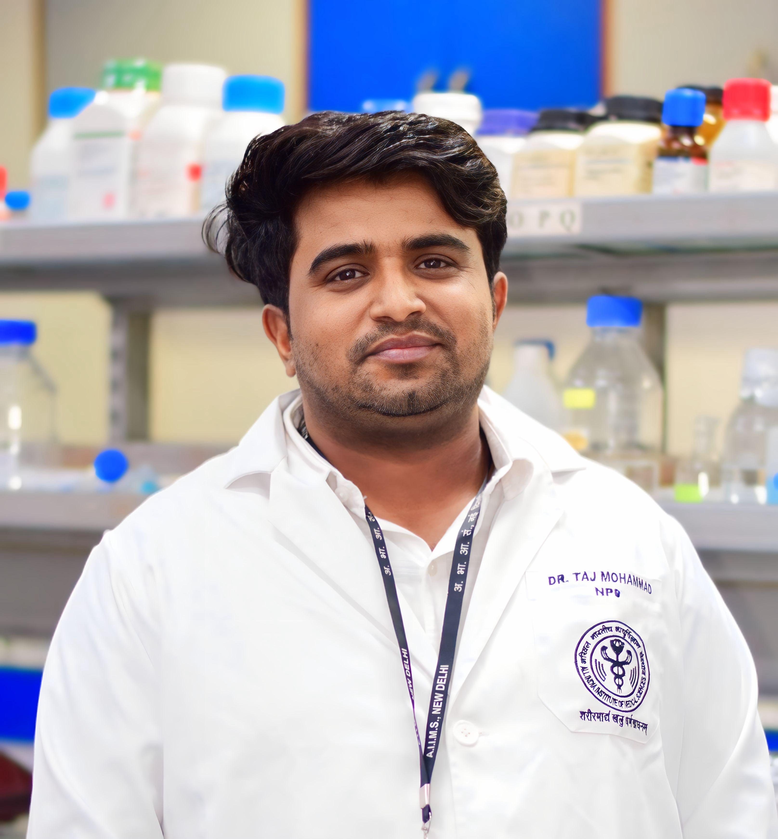
Photograph of the presenting author
Presenter Profile
Write a brief profile of the presenting author (max in 100 words). A sample profile description is “Taj Mohammad is a SERB National Postdoctoral Fellow (N-PDF) at Department of Biophysics, All India Institute of Medical Sciences (AIIMS), New Delhi. Taj obtained his Ph.D. from Jamia Millia Islamia, New Delhi on high-throughput analyses of genomic alterations and differential gene expression in prostate cancer. His research interests lie in genomic and proteomic analysis over complex diseases and structure-guided drug discovery. His current focus is on the development of easy-to-use GUI platforms for people with non-bioinformatics backgrounds.”

